

SIMATS ENGINEERING

Saveetha Institute of Medical and Technical Sciences
Chennai- 602105

Student Name: Mohammed Farmanullah R Reg. No.: 1972260040
Course Code: DSA0101 Slot: D
Course Name: Object Oriented Programming with C++
Course Faculty: Dr. K. Parimala Kanaga Devan
Project Title: Hospital Resource and Patient Management System with Emergency Bed Allocation
Module Photographs: (3 photographs –Module Photo, Individual student contribution module work in the project and presentation image)
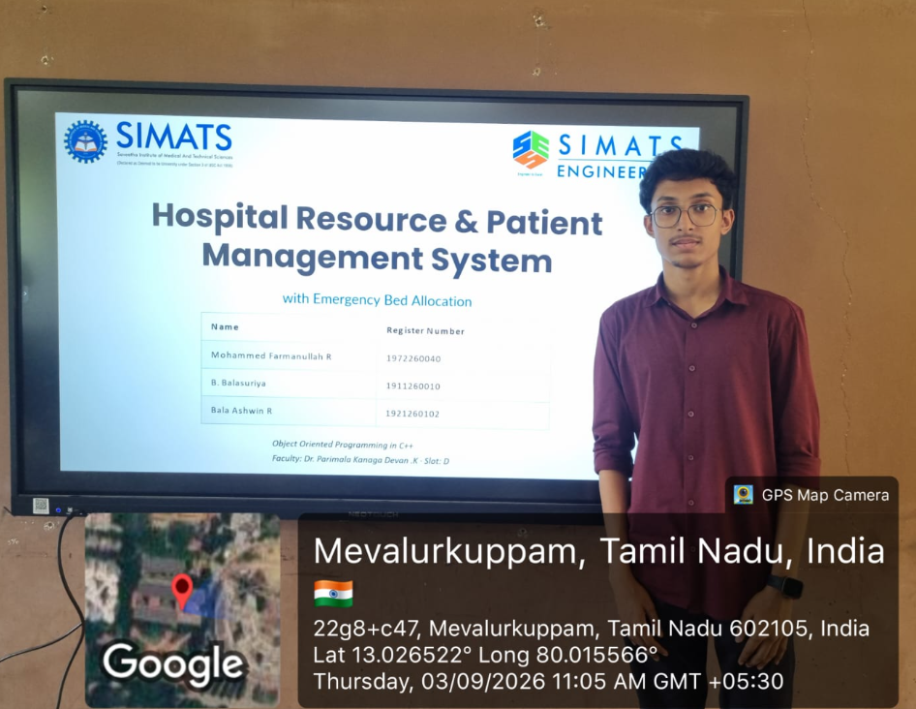
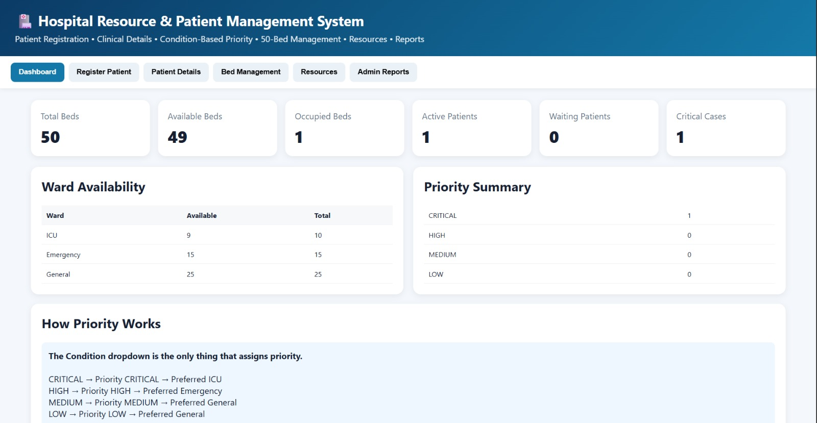
Project Description: (here you write what you did in this project (contribution) including Model Description
In this project, I contributed to the development of a Hospital Resource and Patient Management System. The main objective of the project is to provide a simple and organized method for managing patient information and hospital resources. The system helps maintain important information systematically and makes it easier to access and manage whenever required. My contribution included understanding the project requirements, planning the module, organizing the required information, and developing the necessary functions. I also participated in testing the module, identifying errors, and making improvements to ensure that it worked correctly. I helped integrate my contribution with the other modules of the project so that the complete system could function smoothly. The model demonstrates how a computerized system can be used to manage hospital and patient-related information efficiently. It helps reduce manual work, improves data organization, and provides easier access to information.

Student Signature Guide Signature

